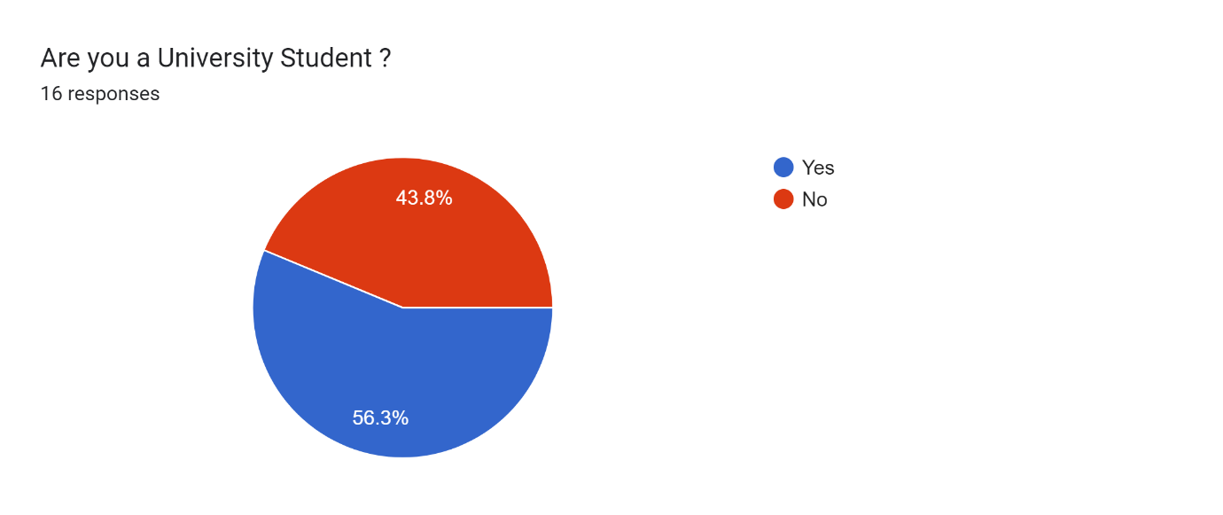

Forms response chart. Question title: (Demographic information)


Which country did you immigrate from?
. Number of responses: 16 responses.

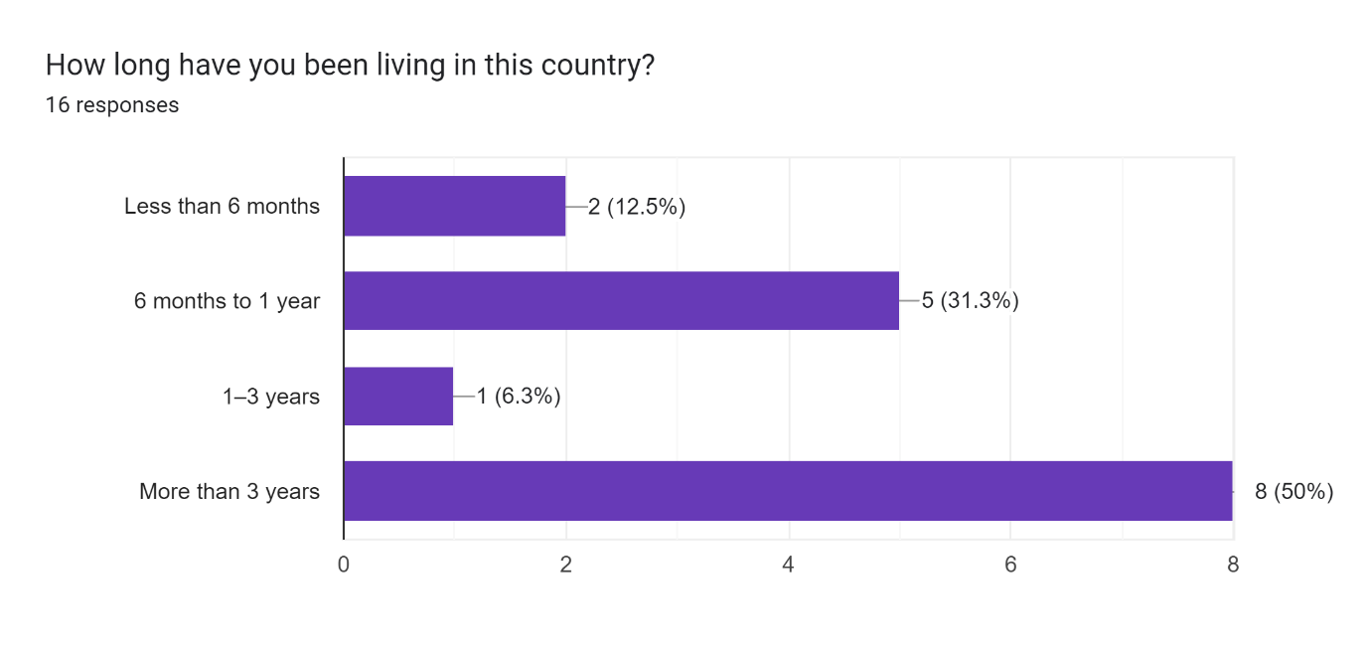

Forms response chart. Question title: What is your age group?

. Number of responses: 16 responses.

Forms response chart. Question title: How often do you travel within your new country?




. Number of responses: 16 responses.

Forms response chart. Question title: What type of places do you usually visit? (Select all that apply)

. Number of responses: 16 responses.

Forms response chart. Question title: Who do you usually travel with?

. Number of responses: 16 responses.

Forms response chart. Question title: What tools do you use to navigate in your new country?



. Number of responses: 16 responses.

Forms response chart. Question title: Do you face language barriers when traveling?

. Number of responses: 16 responses.

Forms response chart. Question title: How do you usually overcome language barriers?


(Select all that apply). Number of responses: 16 responses.

Forms response chart. Question title: Do you have safety concerns when traveling in your new country?

. Number of responses: 16 responses.

Forms response chart. Question title: What are your main safety concerns?
(Select all that apply)

. Number of responses: 16 responses.

Forms response chart. Question title: What type of travel information would you find most helpful?

. Number of responses: 16 responses.

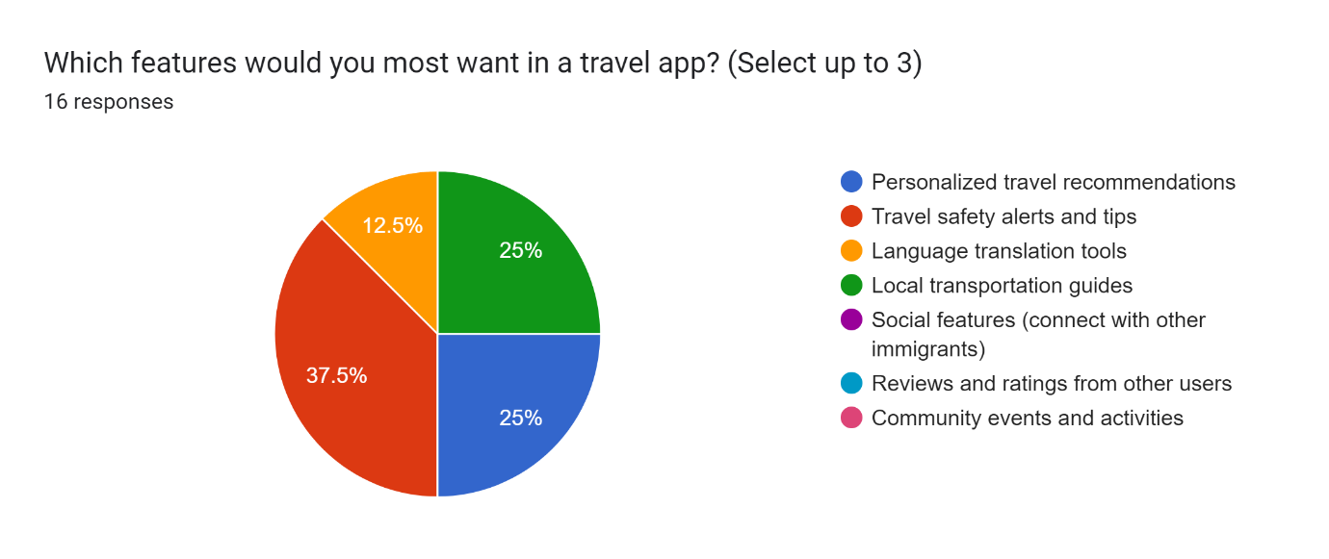

Forms response chart. Question title: How important is it for the app to provide suggestions for culturally significant or immigrant-friendly places?

. Number of responses: 16 responses.

Forms response chart. Question title: Has safety been a barrier for you when exploring new places?


. Number of responses: 16 responses.

Forms response chart. Question title: Have you faced challenges understanding local laws or regulations (e.g., traffic rules, public behavior)?
. Number of responses: 16 responses.

Forms response chart. Question title: Would you like to receive updates on local news, laws, and regulations relevant to the country you are traveling to?
. Number of responses: 16 responses.

Forms response chart. Question title: How important is it for you to have access to information about local health services or pharmacies when you are traveling?
. Number of responses: 16 responses.

Forms response chart. Question title: Would you feel confident using the local public transport? Why or why not?
. Number of responses: 16 responses.

Forms response chart. Question title: Would you prefer a tailored app with tips and content for traveling to a new country?
. Number of responses: 16 responses.

Forms response chart. Question title: How comfortable are you with interacting with locals or fellow tourists?
. Number of responses: 16 responses.

